
Symbiosis Institute of Technology, Pune
Faculty of Engineering
CSE- Academic Year 2026-27
Java Programming – Lab Batch 2024-28
Lab Assignment No:- 14
Name of Student | Aarushi Raizada
PRN No. | 25070122002
Batch | 2025-29
Class | A1
Academic Year & Semester | 2026 Sem III
Date of Submission | 24th August’26
Title of Assignment: | Write a Java program to demonstrate exception handling using try and catch blocks, nested and multiple try-catch blocks.
Theory  Practice questions | Exception handling prevents abnormal termination of programs due to runtime errors. The try block contains code that may generate exceptions, while catch blocks handle specific exceptions. Nested and multiple try-catch structures allow complex error management. Exception handling improves software reliability and user experience by gracefully managing unexpected situations.  1. Create an ATM program handling invalid withdrawal amount using try-catch  import java.util.Scanner;  public class trycex {  public static void main(String[] args) {  Scanner sc = new Scanner(System.in);  try {  System.out.print("Enter withdrawal amount: ");  int amount = sc.nextInt();  if (amount <= 0) {  throw new Exception("Invalid withdrawal amount");  }  System.out.println("Withdrawal successful");  }  catch (Exception e) {  System.out.println("Error: " + e.getMessage());  }  }  }  2. Create an Online Shopping program that handles an invalid product quantity entered by the user using a try-catch block. Display an appropriate error message if the quantity is less than or equal to zero.  import java.util.Scanner;  public class trycex2 {  public static void main(String[] args) {  Scanner sc = new Scanner(System.in);  try {  System.out.print("Enter product quantity: ");  int quantity = sc.nextInt();  if (quantity <= 0) {  throw new Exception("Quantity must be greater than zero");  }  System.out.println("Product added successfully");  }  catch (Exception e) {  System.out.println("Error: " + e.getMessage());  }  }  }
Output Screenshots (if applicable) | Ans 1  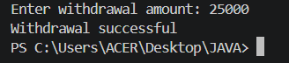  Ans 2  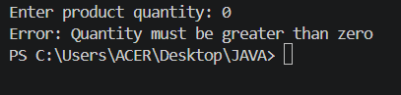
Conclusion | In this experiment, we learnt to handle runtime exceptions using try-catch, nested try, and multiple catch blocks.

